JavaScript Objects
(TASK22)

1. Creating an Object
An object stores data as key-value pairs and can also include methods (functions).
// Create an object with name, age, and method sayHello().
console.log("Create an object with name, age, and method sayHello().")
let obj={id:1,name:"john",age:22, sayhello: function(){
console.log("this is my name "+ this.name);
}
};
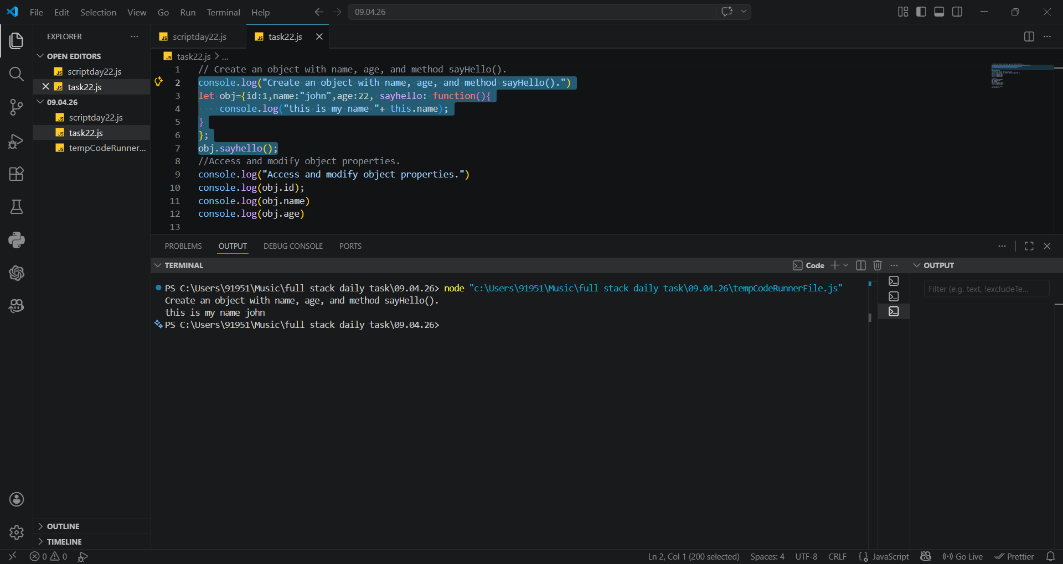
Output:

2. Accessing and Modifying Properties
Properties can be accessed using dot notation and modified by assigning new values.
console.log(obj.name); // John
console.log(obj.age); // 25
person.age = 30;
console.log(obj.age); // 30
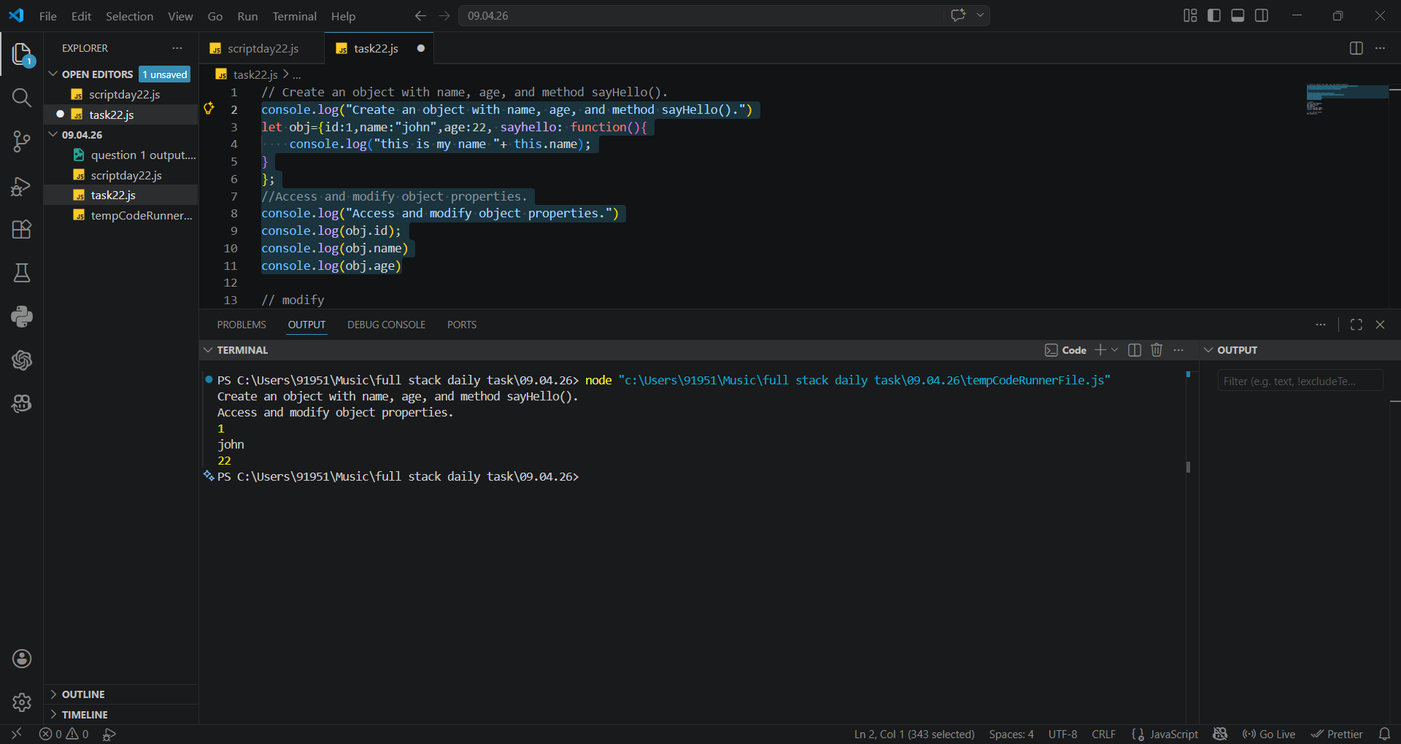

3. Calling an Object Method
A method is a function inside an object and is called using objectName.methodName().

person.sayHello();
// Output: Hello, my name is John

4. Full Example
Complete example combining object creation, access, modification, and method call.
// Create an object with name, age, and method sayHello().
console.log("Create an object with name, age, and method sayHello().")
let obj={id:1,name:"john",age:22, sayhello: function(){
console.log("this is my name "+ this.name);
}
};
//Access and modify object properties.
console.log("Access and modify object properties.")
console.log(obj.id);
console.log(obj.name)
console.log(obj.age)

// modify
console.log("modify")
obj.name="alice"
obj.age=30;
console.log(obj.name);
console.log(obj.age);

// call method object
obj.sayhello();

